Project Design Phase
Solution Architecture

Date | 22 February 2026
Team ID | LTVIP2026TMIDS42033
Project Name | Weather-Based Prediction of Wind Turbine Energy Output: A Next-Generation Approach to Renewable Energy Management
Maximum Marks | 4 Marks

Solution Architecture
Solution architecture is a structured process that connects renewable energy management challenges with intelligent technological solutions. In the proposed Weather-Based Prediction of Wind Turbine Energy Output System, the architecture integrates real-time weather data, machine learning models, and an interactive dashboard to deliver accurate wind energy forecasting.
The goals of this solution architecture are to:
● Identify and implement the most effective technology stack for real-time wind turbine energy prediction.
● Clearly describe the system structure, components, data flow, and interactions for stakeholders and evaluators.
● Define system features including weather API integration, backend processing, machine learning prediction, and analytics visualization.
● Provide technical specifications that guide development, deployment, scalability, and future enhancements of the renewable energy management platform.
Example - Solution Architecture Diagram:
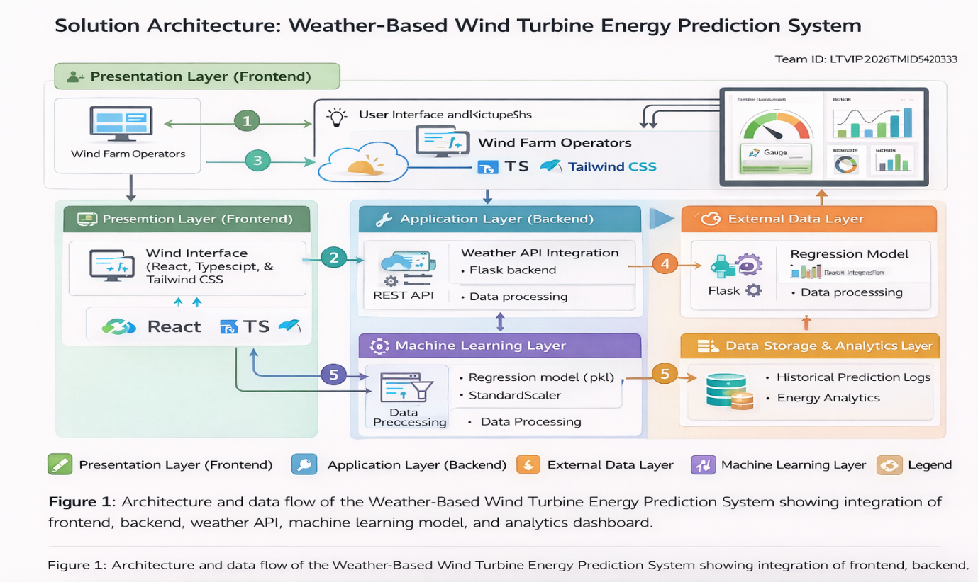
Reference: https://aws.amazon.com/blogs/industries/voice-applications-in-clinical-research-powered-by-ai-on-aws-part-1-architecture-and-design-considerations/

